Installation Guide

jWebSocket
SMS Gateway
Mayra Eva Marañón Rodriguez

1. Process application download
For the installation of this application should be downloading the packages containing the client and server jWebSocket. The url address where the application is available for download is http://jwebsocket.org/downloads .
Packages | Size
SMS Server | 111,1 Kb
jCaptcha Server | 96,3 Kb
SMSGateway Client | 241,3 Kb

2. Installation process
You want to install the application on the Linux operating system the package containing the application client must be copied var / www, to do this you need to install Apache. In addition it should be given all permits through the console. The package contains the server can be stored in any location. Before running the client browser must be set to run the server on an IDE.
If the operating system is Windows should have installed the Wamp application that creates the folder C: \ \ wamp \ www, this is to copy the package containing the client. The package contains the server can be stored in any location. Before running the client browser must be set to run the server on an IDE.
5. Operation
To run the application should start the server and then open jWebSocket client SMSGateway in any of the browsers supported by WebSocket.

6. SMSGateway Configuration
The jCaptcha plugin and SMS plugin settings can be managed in rte/jWebSocket-1.0/conf/jWebSocket.xml, where you can also configure other plugins. Below are the plugins configurations for jWebSocket:
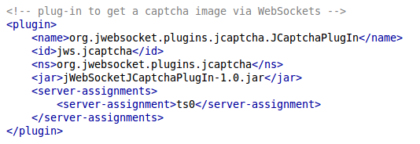
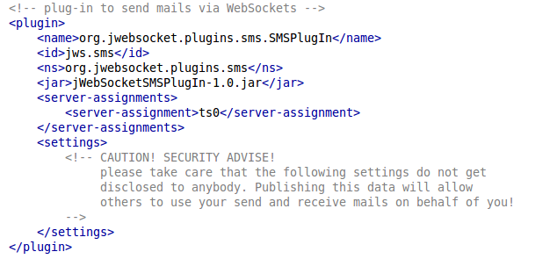
7. Application Management
To administer SMSGateway can be supported in the user manual.
In the event of any problems during installation of the application, contact:
Mayra Eva Marañón Rodriguez
mail: memaranon@hab.uci.cu

